DSP Homework-2 (ver1.0)
Simulation of RC Low-Pass Filter by Discrete Signal Processing
2020/10/15

作業學習目標
- 了解Linear Constant-Coefficient Difference Equation (LCCDE) 的由來以及原理
- 對於 Sampling Rate 有初步的認識
- 了解怎麼由連續時間的處理轉變成離散信號的處理

作業內容
Background:
Input voltage, output voltage
Note: input and output are functions of time.
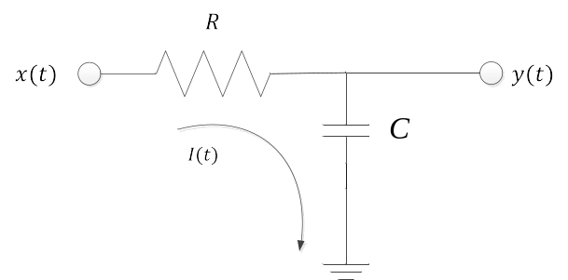
We want to find a solution for output in term of, and. By KVL, we obtain
where is value of charge for the capacitor. By characteristics of the capacitors, we known

Then we replace in Eq. (1) with in Eq. (2):


Basically Eq. (1) is a differential equation and we can re-write Eq. (3) by definition of differentiation:

Then we approximate Eq. (4) as is very small:

By observing Eq. (5), we known that the solution of Eq. (5) could be very close to Eq. (4) if is very small. If we want to use computer to simulate Eq. (4) or Eq. (5), we must “discretize” the continuous signal of & by setting where is sample index (so must be a integer):

Since is an integer we only have to consider “discrete” samples. We denote discrete signal by
Then we re-write Eq. (6) by

Because it is conventional to put output on the left-handed side and input on the right-handed side, Eq. (7) is re-written by

It is noted that Eq. (8) can be implement in an iterative manner, i.e. by for loop, and the constant “” is sampling period.

Homework Assignment:
- If, find. Note that can be expressed by where is a function of with parameters of and. If you can find you find the solution of of (By handwriting mathematics. Please keep the calculation process on your paper).
- If 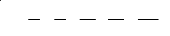; find for, (By handwriting mathematics. Please keep the calculation process on your paper).
- Simulate by C programs for the problem (2) with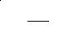,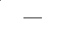, 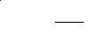. (Please also submit your C code to the e-learning system)
Caution! Please don’t just put results in the paper. Discussions for the results are required!

